Abstract

Parallax handling is a challenging task for image stitching. Our implementation makes use of a local stitching method to handle parallax based on the observation that input images do not need to be perfectly aligned over the whole overlapping region for stitching. Instead, they only need to be aligned in a way that there exists a local region where they can be seamlessly blended together. We adopt a hybrid alignment model that combines homography and content-preserving warping to provide flexibility for handling parallax and avoiding objectionable local distortion. We then develop an efficient randomized algorithm to search for a homography, which, combined with content-preserving warping, allows for optimal stitching. We predict how well a homography enables plausible stitching by finding a plausible seam and using the seam cost as the quality metric. We develop a seam finding method that estimates a plausible seam from only roughly aligned images by considering both geometric alignment and image content. We then pre-align input images using the optimal homography and further use content-preserving warping to locally refine the alignment. We finally compose aligned images together using a standard seam-cutting algorithm and a multi-band blending algorithm. Our experiments show that our method can effectively stitch images with large parallax that are difficult for existing methods.

Literature Review

Image stitching or photo stitching is the process of combining multiple photographic images with overlapping fields of view to produce a segmented panorama or high-resolution image. Parallax handling is a challenging task for image stitching. We present a local stitching method to handle parallax based on the observation that input images do not need to be perfectly aligned over the whole overlapping region for stitching. We then develop an efficient randomized algorithm to search for a homography, which, allows for optimal stitching.

Image stitching is a well-studied topic [22]. Its first step is to align input images. Early methods estimate a 2D transformation, typically a homography, between two images and use it to align them [23, 3]. Since a homography cannot account for parallax, these methods require that the input images should be taken from the same viewpoint or the scene should be roughly planar. Otherwise, no homography exists that can be used to align these images, resulting in artifacts like ghosting or broken image structures. While advanced image composition techniques, such as seam cutting [2, 12] and blending [4, 17], can relieve these artifacts, they cannot address significant misalignment.

Pipeline

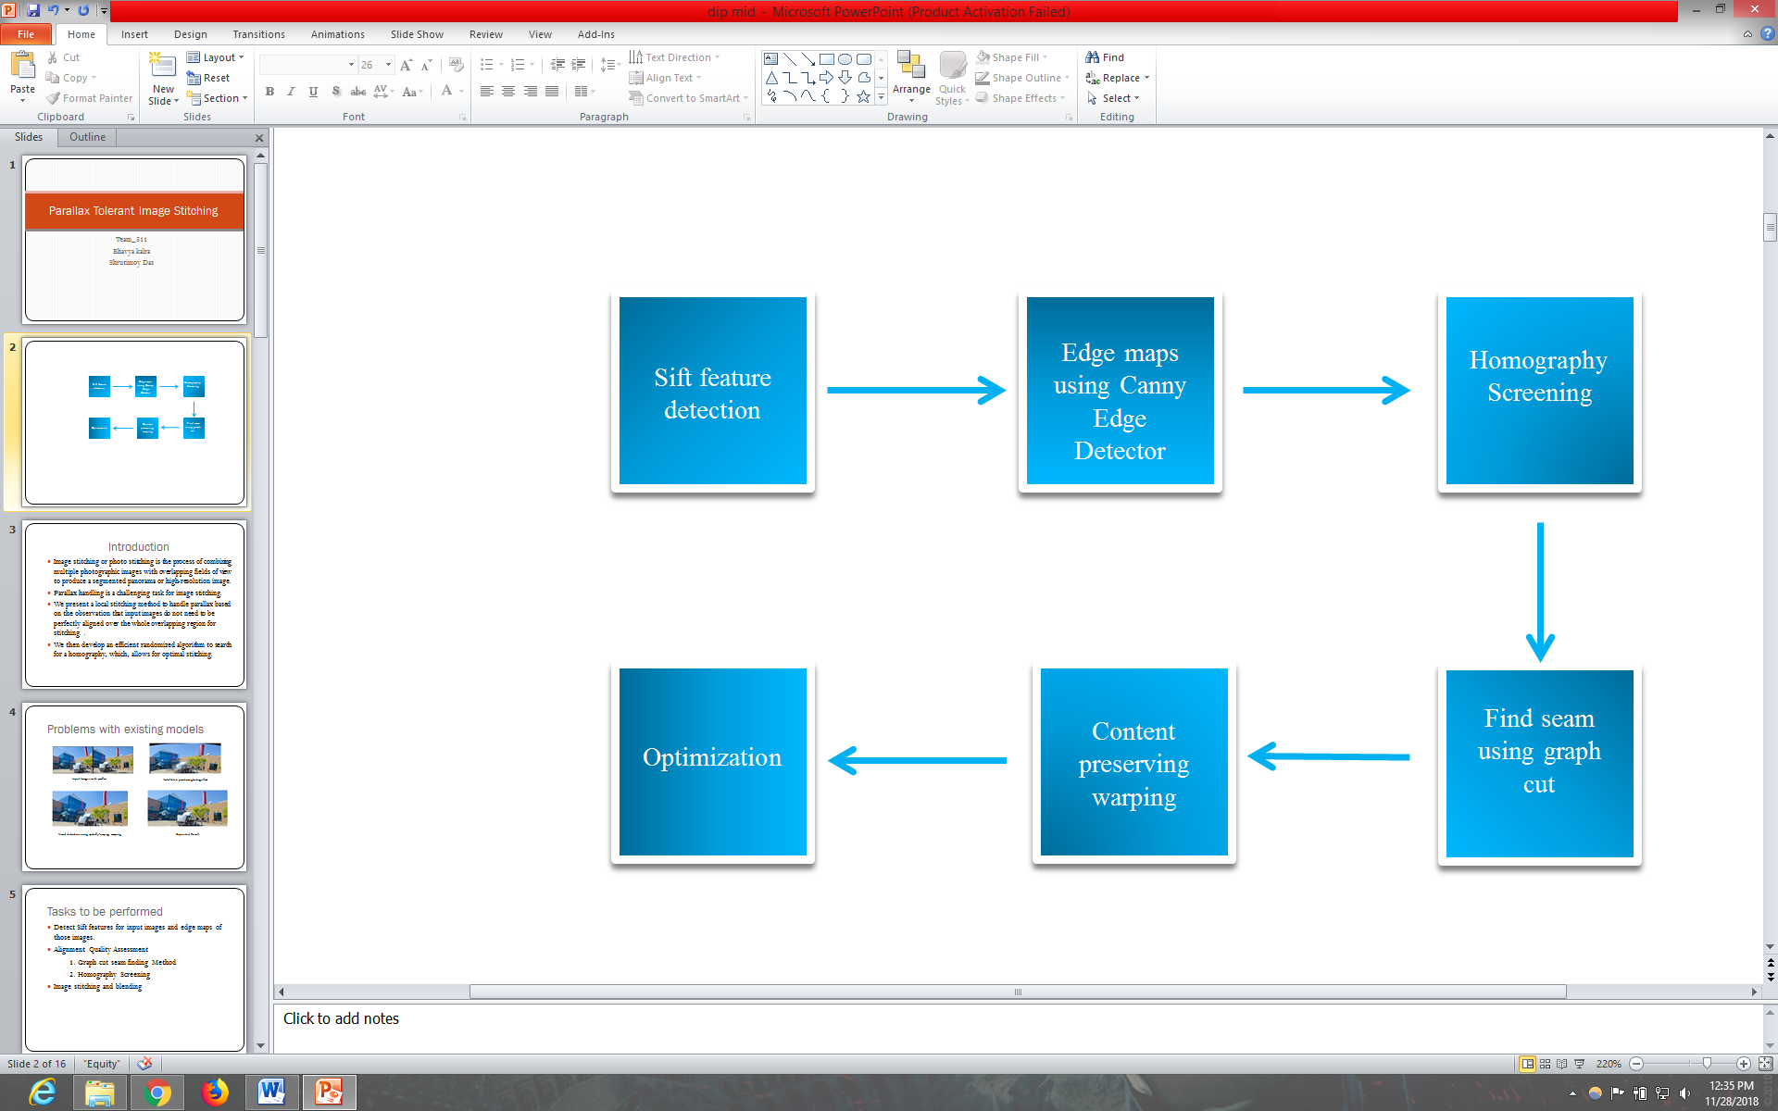

Algorithm

1. Detect and match SIFT features between input images [15] and estimate edge maps for input images [5].
2. Randomly select a seed feature point and group its spatially nearest neighbors one by one until the selected feature set cannot be fitted by a homography with a pre-defined threshold. We maintain a penalty value for each feature point to identify the times that it has been selected during the iteration process. When a feature point is selected, we increase its penalty value by one. In each iteration, to be selected as a valid seed, a feature point should not have been selected as a seed before and its penalty score is below the average penalty value of all the feature points.
3. Evaluate the alignment quality of the best-fitting homography from Step 2. If the homography meets the pre-defined quality threshold, go to Step 4. Otherwise, if the average penalty value is low, go to Step 2; otherwise select the best homography estimated during the iteration process and go to Step 4.
4. Employ the optimal homography to pre-align images and use content-preserving warping guided by the set of selected feature points to refine the alignment.

Sift feature Mapping

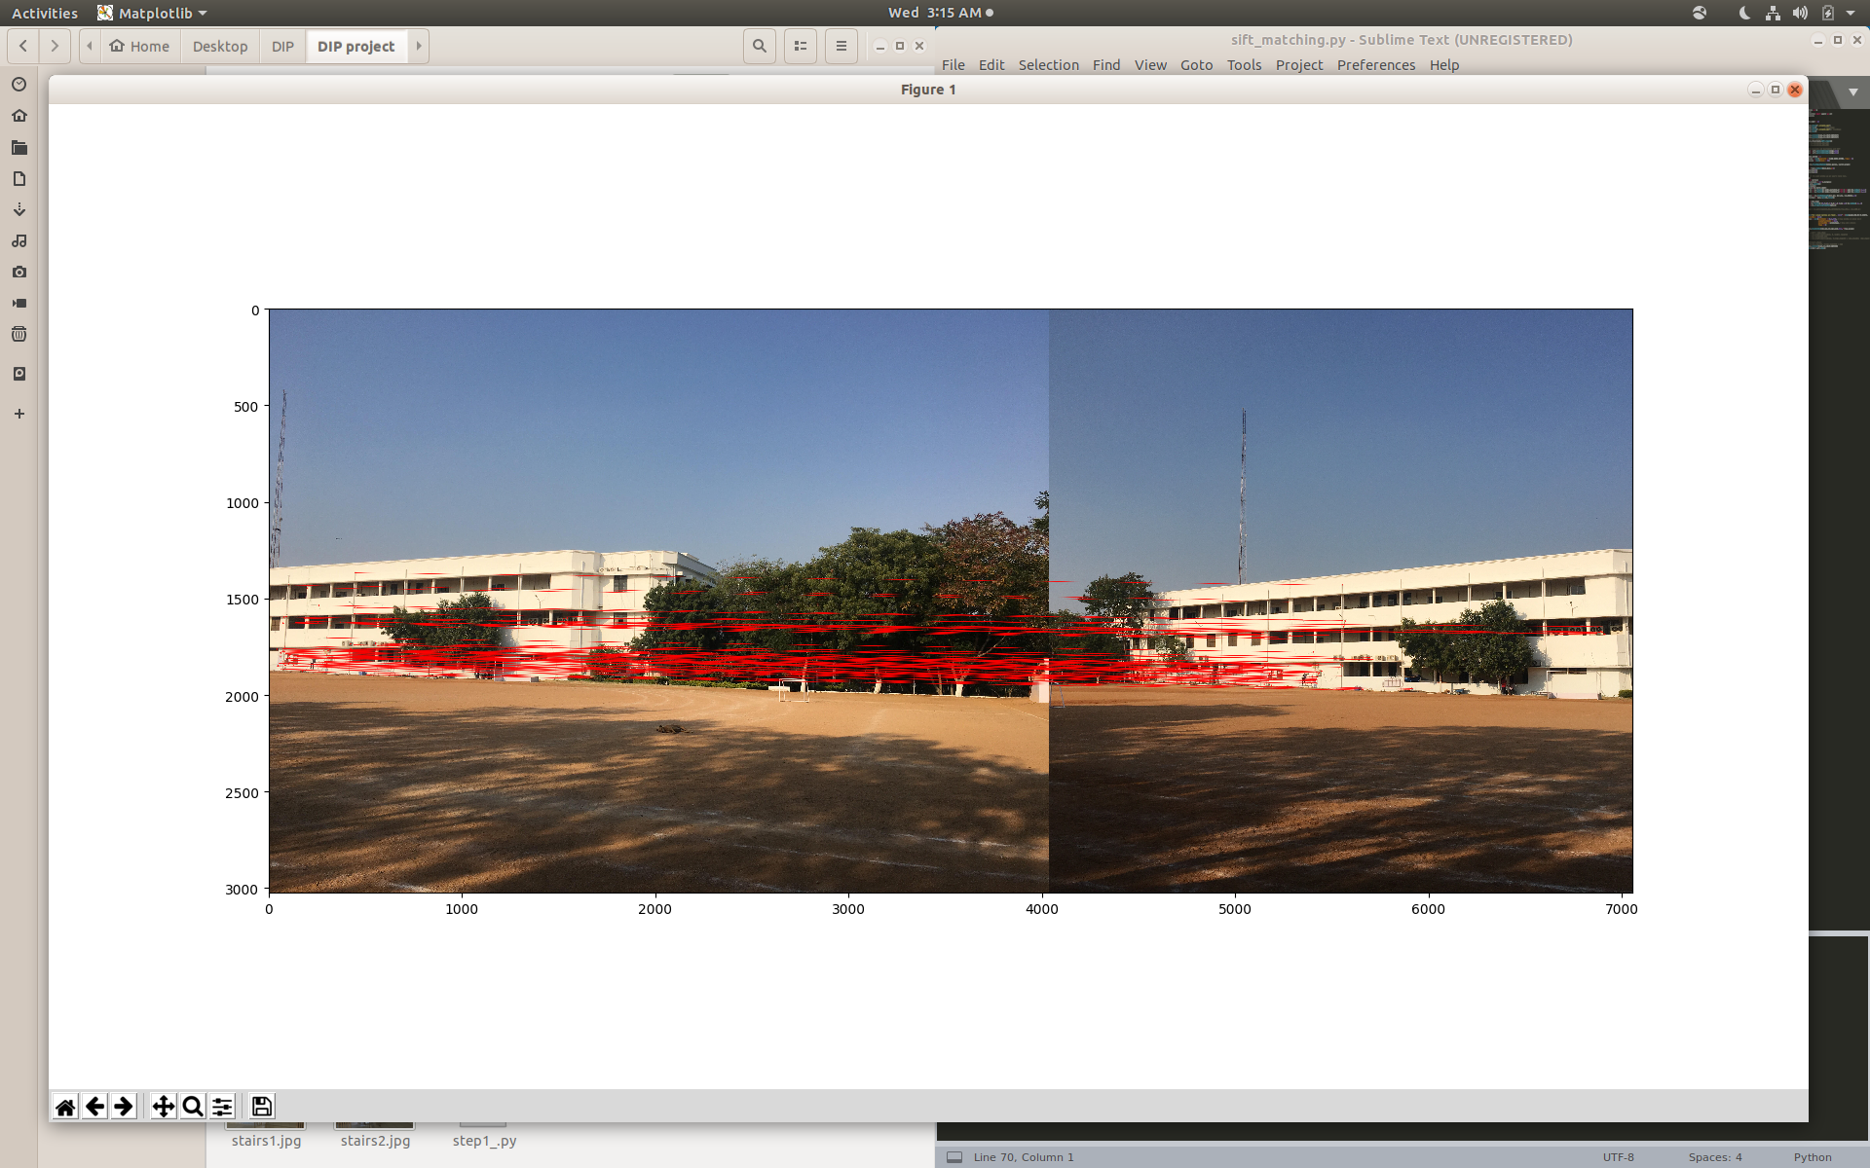

Sift features matching in the two parallax induced Images

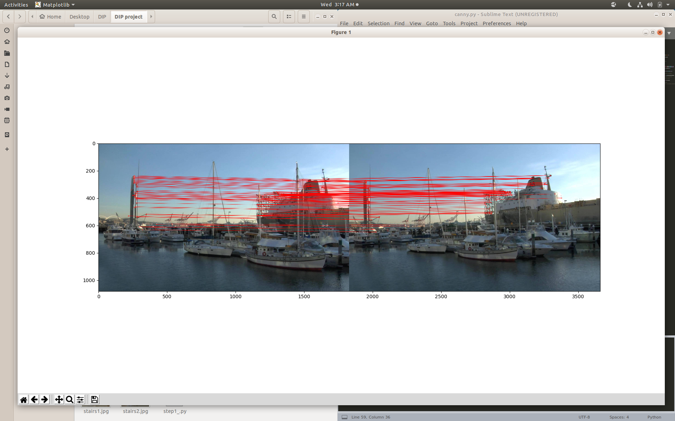

Sift features matching in the two parallax induced Images

Sift feature matching on Edge Maps

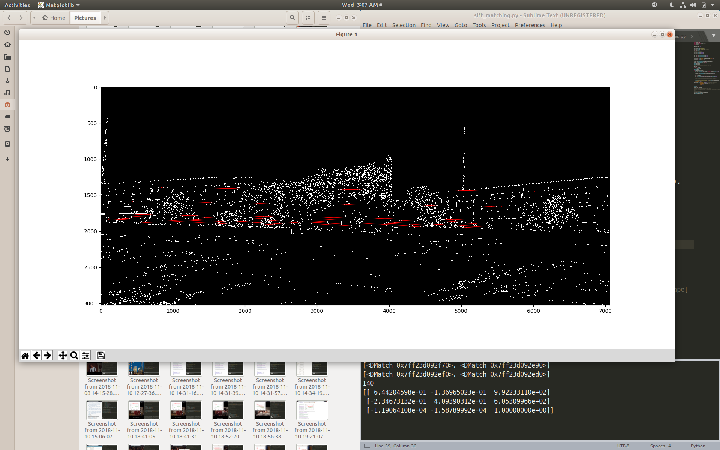

Sift features matching canny edge maps of two Images

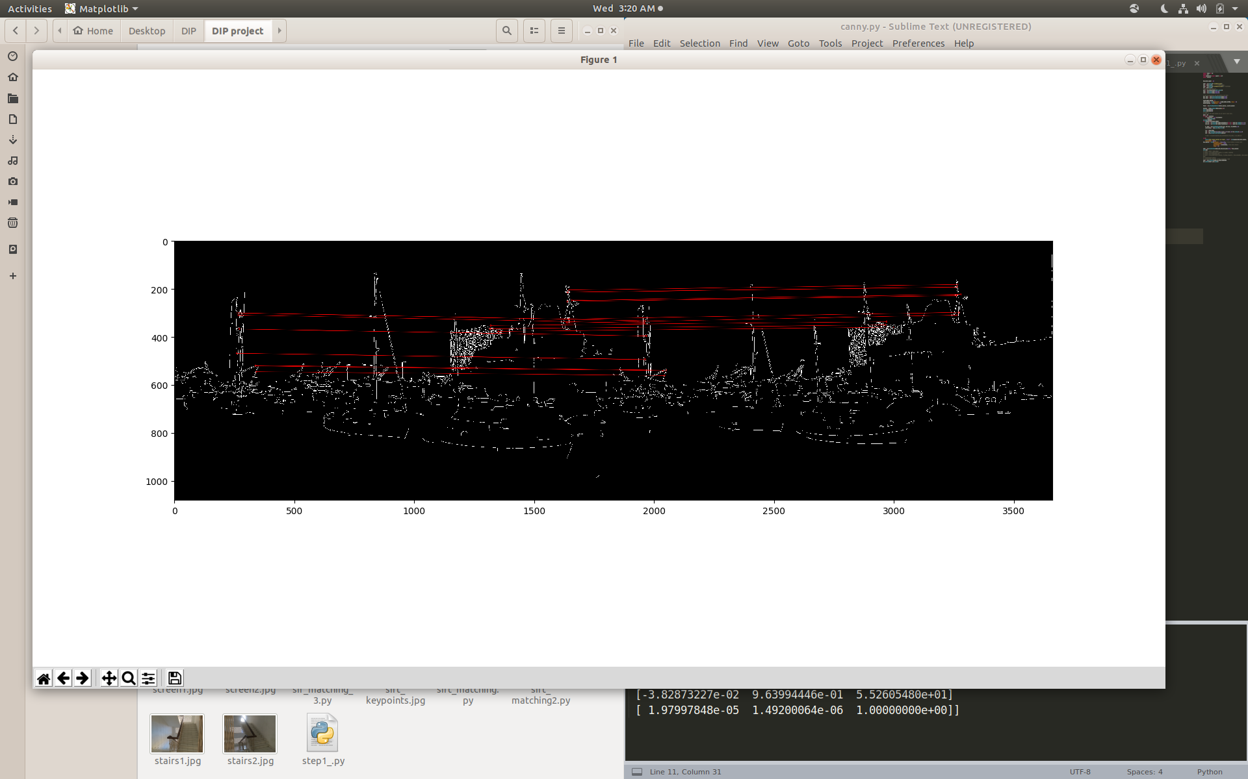

Sift features matching canny edge maps of two Images

Homography Screening

Insert resulting Images

Finding seam using Graph Cut

Insert resulting Images

Resulting Blended Images

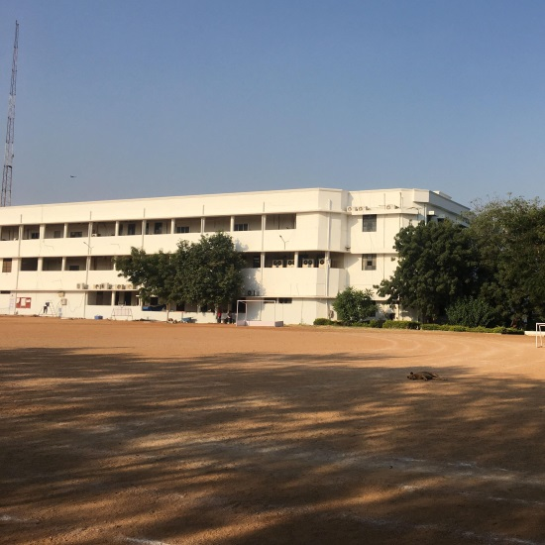 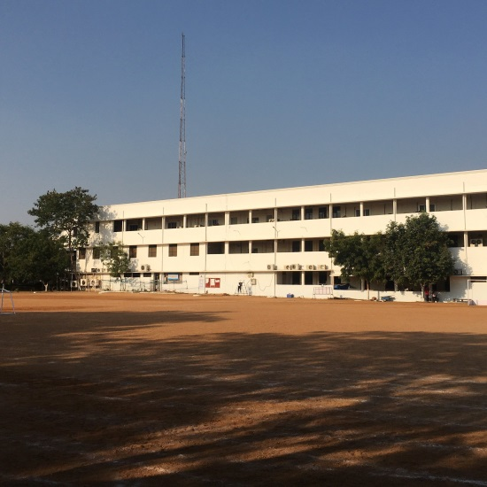

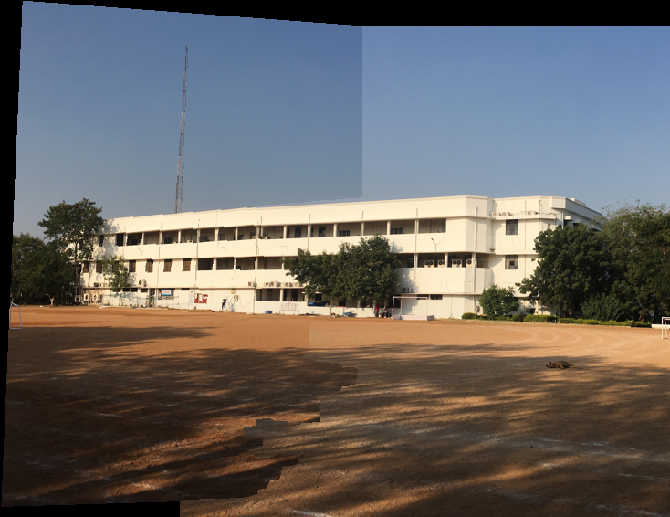

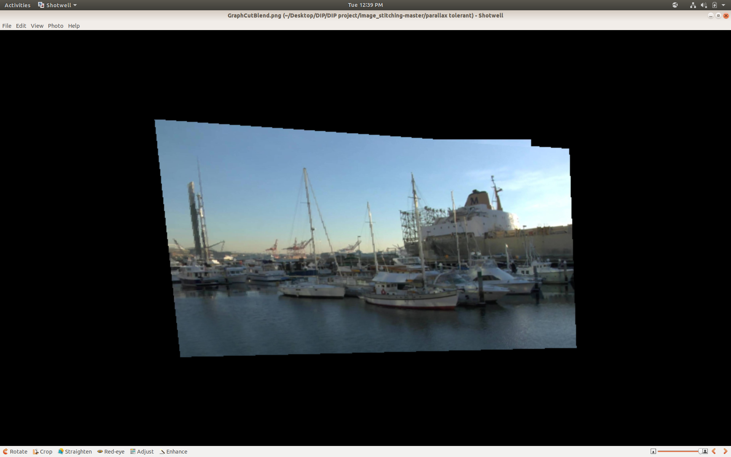

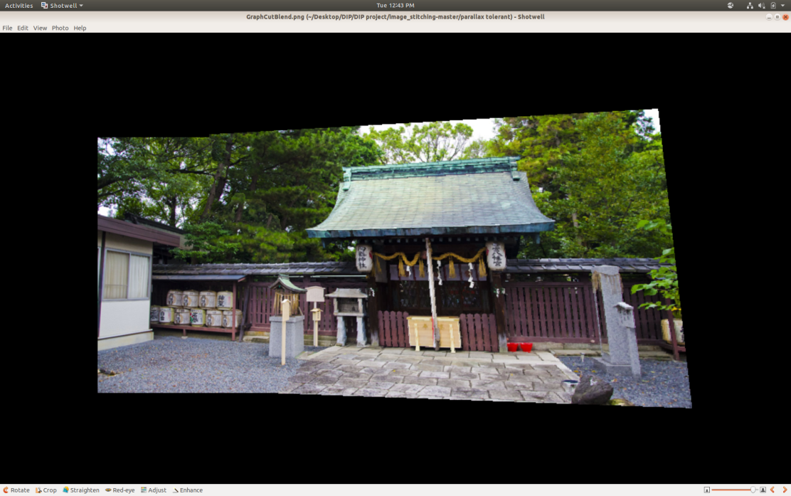

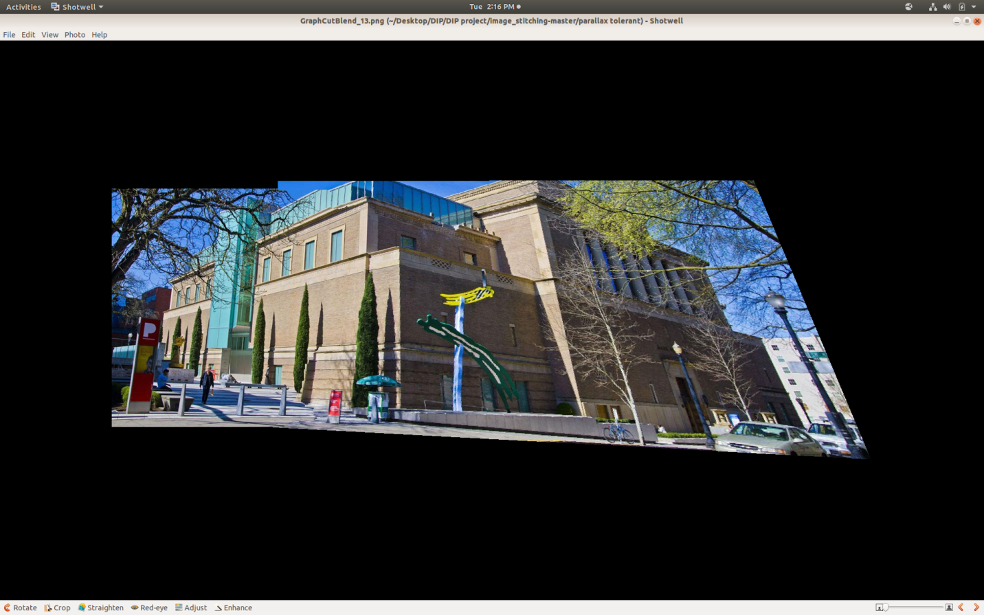

Incorrect Results

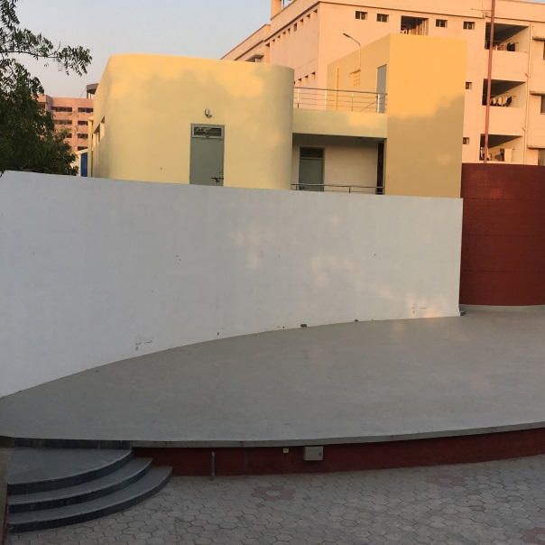 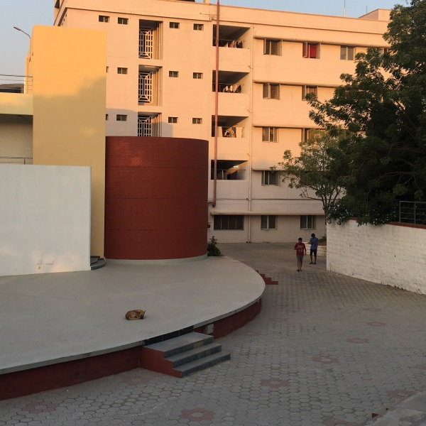

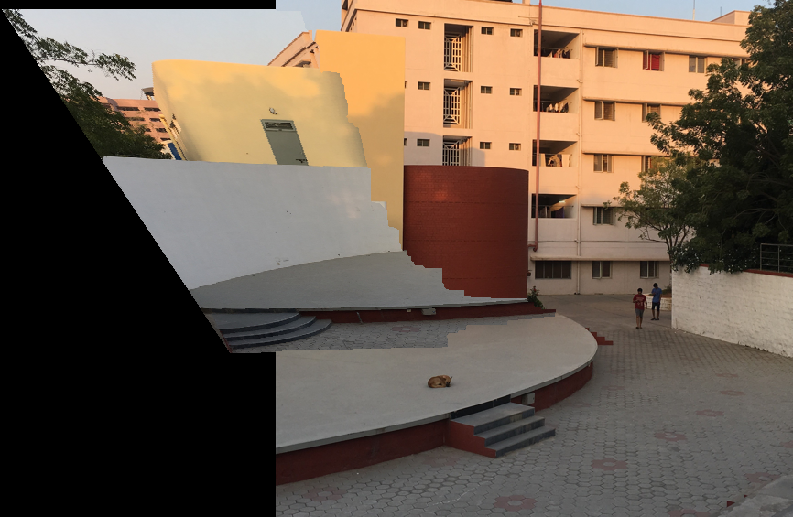

Conclusions:

We were able to achieve our objectives of implementing a method to stitch images containing parallax. The use of sift features, canny edge maps, graph cut method provided us with image alignment assessment. Also, we were able to blend the images together by using multiple scales of the input images and different constraints on homography matrix. However, images with major parallax didn’t produce the right blending even though homography found was marginally incorrect.

Biblography